Best framework

DIY – Pattern – Express and Restify

Defining a Router in Express,

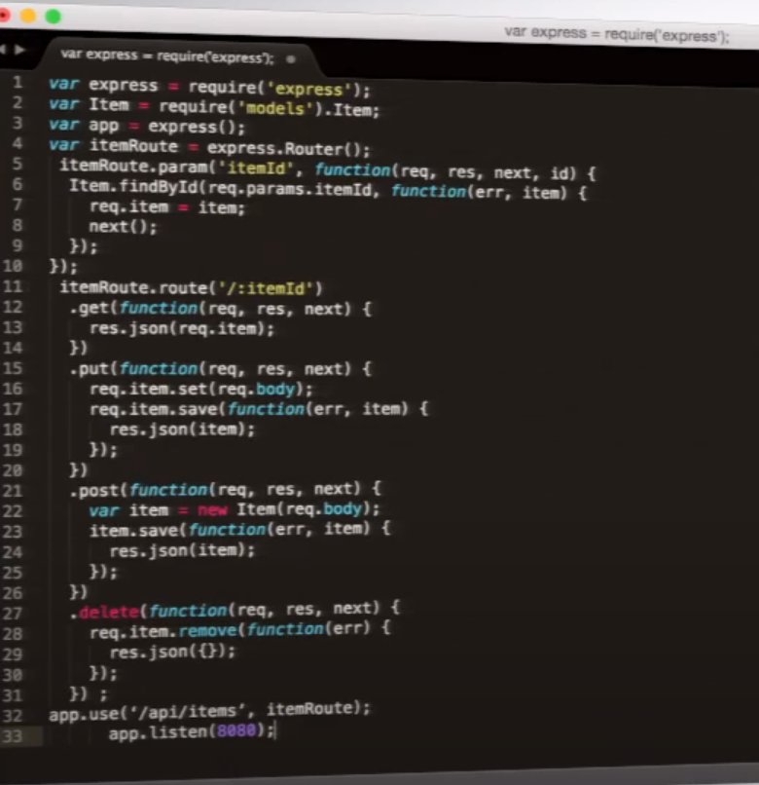

Restify

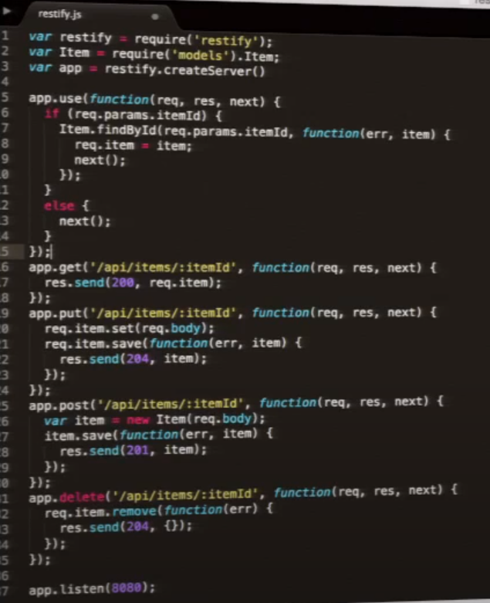

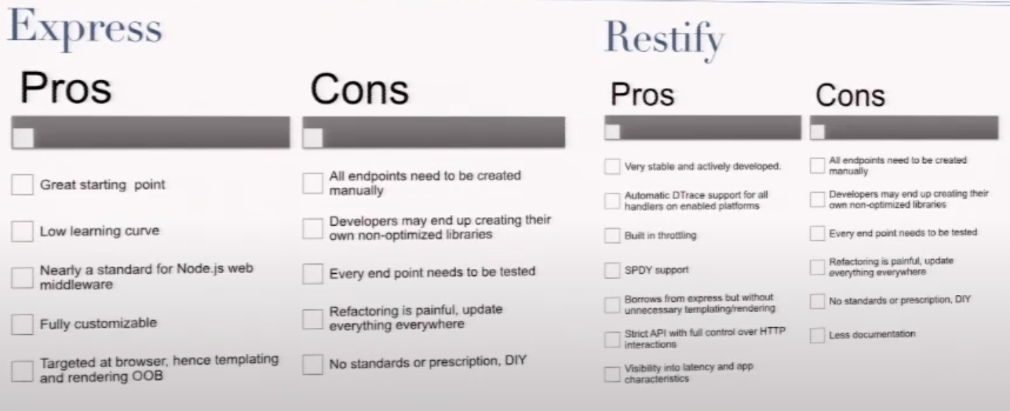

Pattern 2 – Configuration

Hapi – To control the Webserver

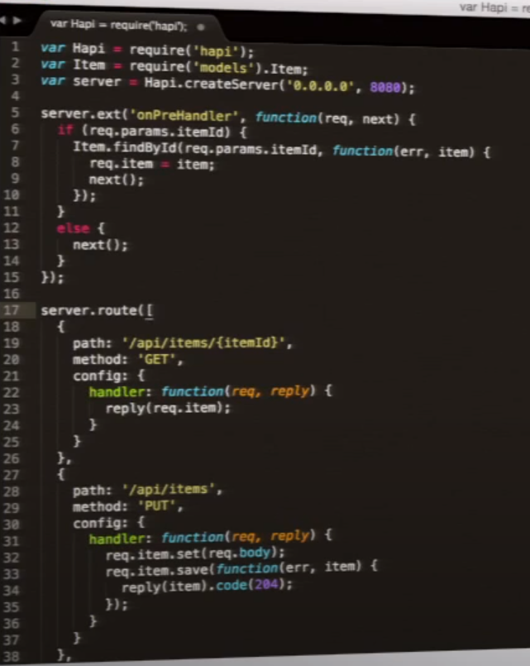

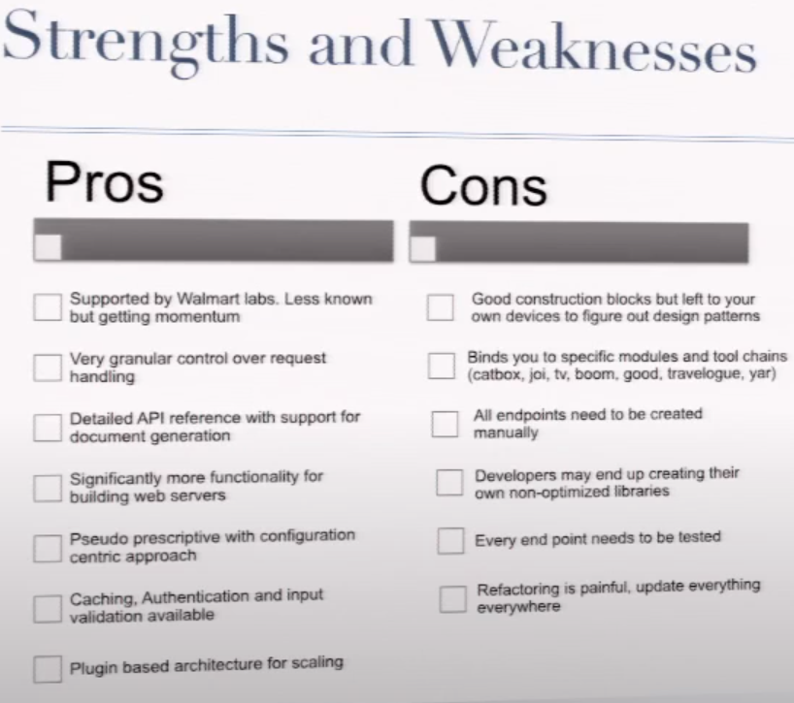

Pattern -3 – ORM

**Model Driven Dev**,

Any Datasource(Relational Datasource, Object Json Driven Datsource Mongo DB, Consuming REST API or SOAP API),

Automatic REST API Generator

LoopBack on top of Express

Router Example

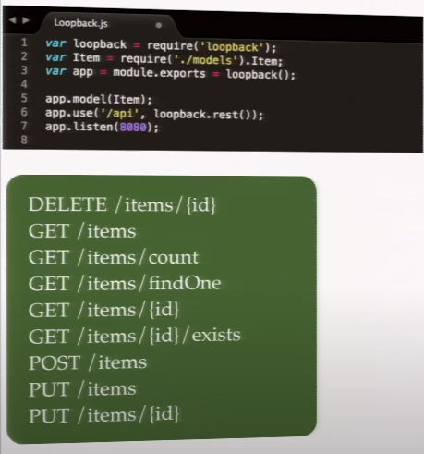

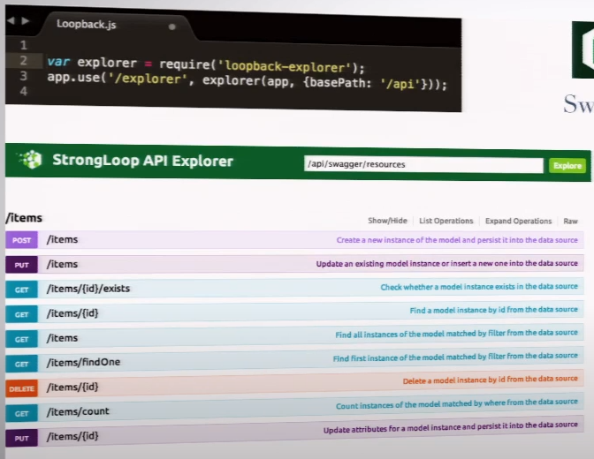

Sails.js

Router example

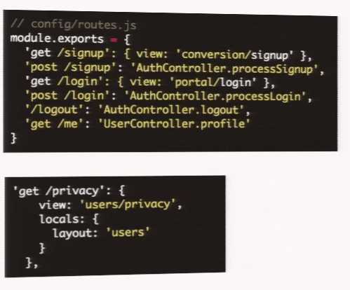

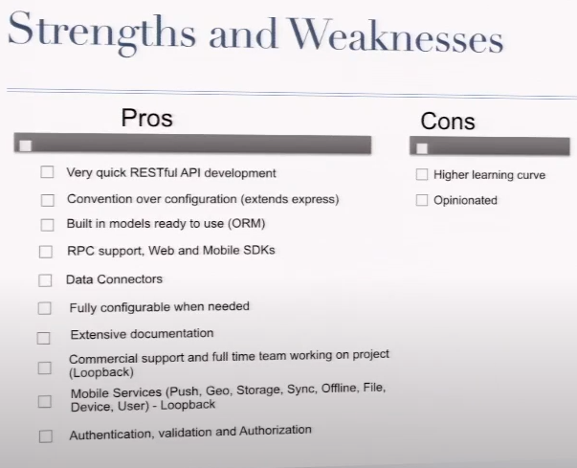

Pattern – 4 – Isomorphic JS and Full Stack

Share Server Model with Client / Remoting

Omni- Channel (Mobel, Web, IOT)

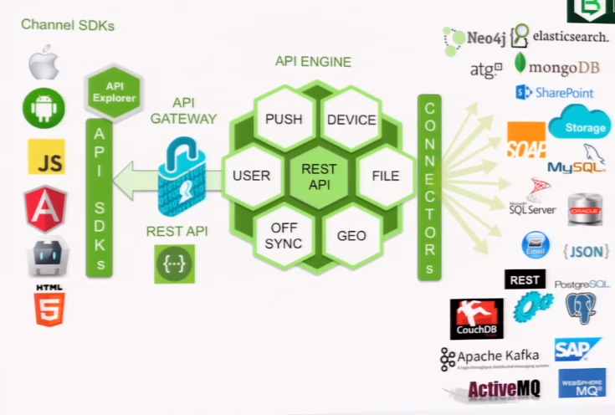

Meteor

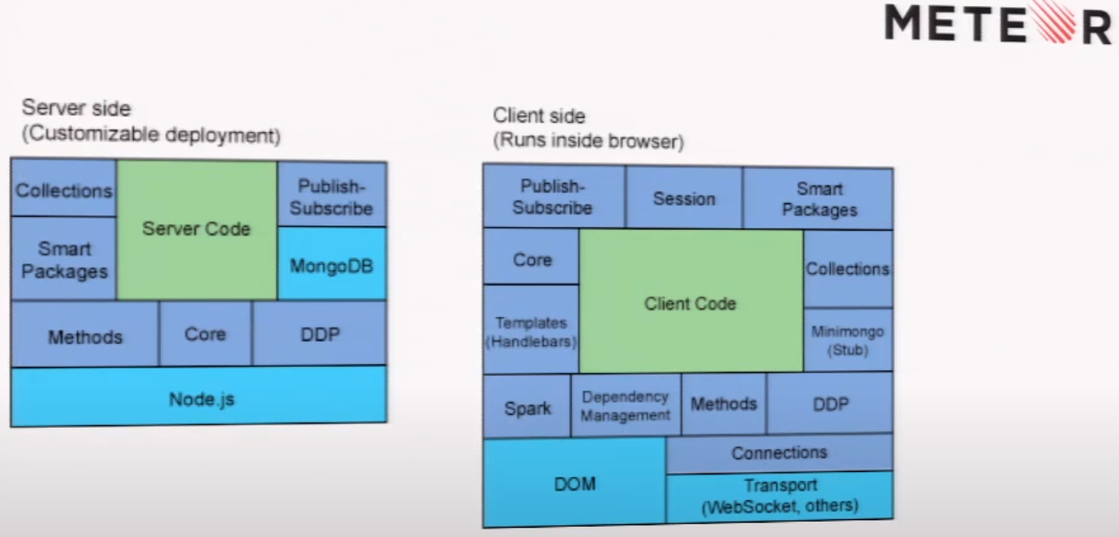

Pattern 5 – Microservice

Decomposition

Containment

Flexibility

Hyperscale

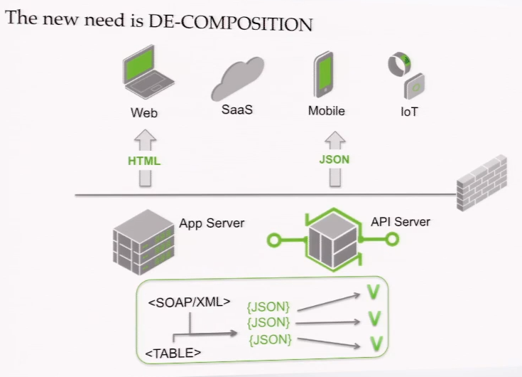

Design

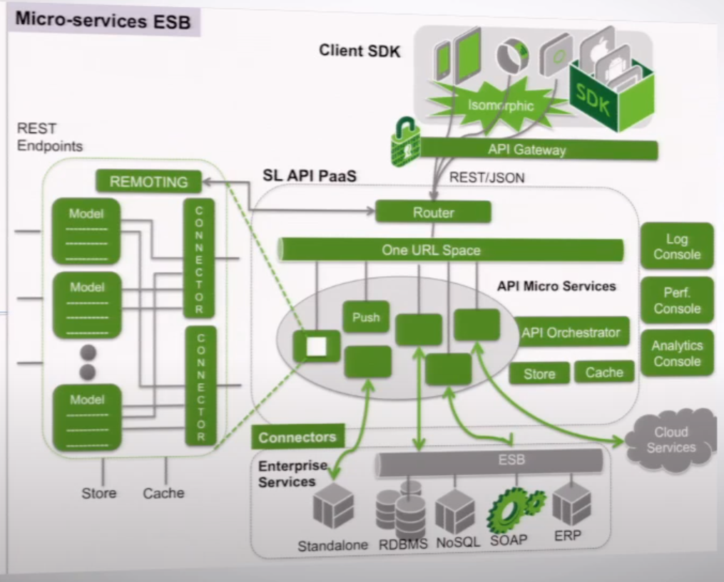

Runtime

The service container could be the docker for e.g.

